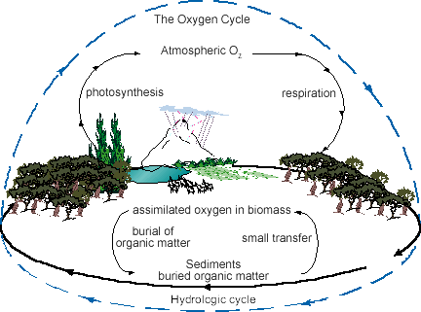

- Oxygen used during respiration, produced during photosynthesis (opposite of carbon)

- Oxygen is recycled in the soil through the decay and decomposition of organic matter

- Oxygen binds with hydrogen molecules in atmosphere, entering into the water cycle

