3 Major Experiments associated with The Origin of Life
Redi’s Experiment:
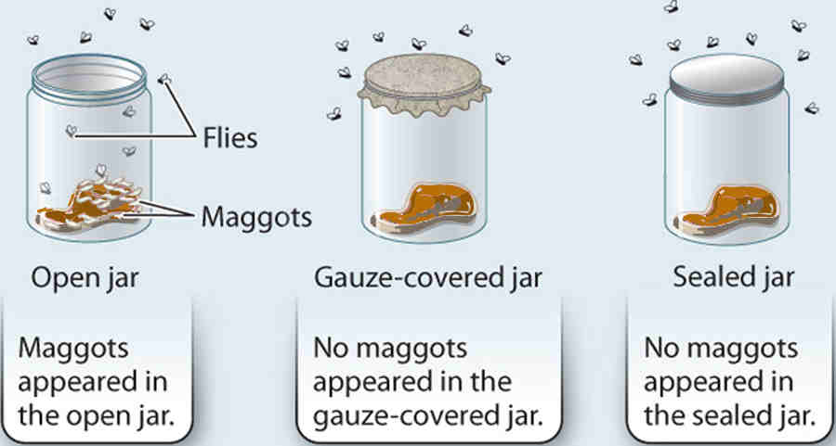
Pasteur’s Experiment:
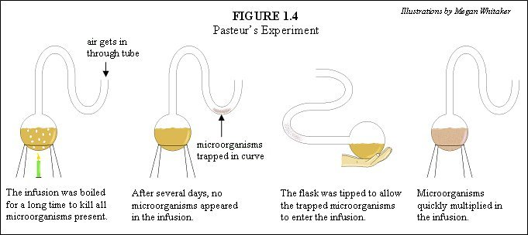

Miller-Urey’s Experiment:
