

Introduction
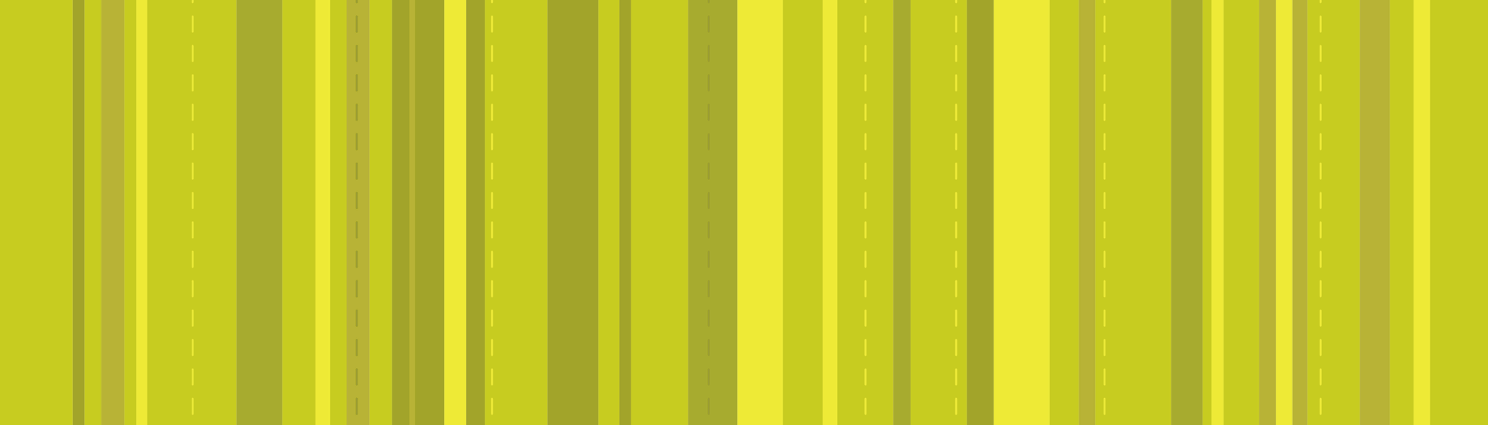

How Science Works

Cd Scientists test an explanation by seeing if specific predictions based upon it are in agreement with data from observation or from an experiment (a deliberate intervention to generate data). If data agree with predictions that are very novel or unexpected, this is particularly influential. The aim is to rule out alternative explanations, and so reach a single explanation that most scientists can agree on.
Ch A scientific theory should lead to predictions that are precise and detailed enough for it to be possible that they can be shown to be false (falsification). A theory is ‘non-scientific’ if it does not make any predictions that could possibly be falsified.

Darwin’s theory of evolution has become universally accepted within science, because it explains observations and because there is considerable evidence. This activity looks at the evidence provided by mammalian limbs.

The activity

Science explanations

Ga The first living organisms are thought to have developed from molecules that could copy themselves. All the Earth’s present species, and the many more species that are now extinct, evolved from the same very simple life forms that first appeared on Earth about 3.5 billion years ago. All species can therefore be linked in a single branching tree structure in which many of the branches are ‘dead ends’.

Gb One of the mechanisms central to the explanation of evolution is natural selection. There is usually variation between individuals of the same species. Some have characteristics which give them a better chance of surviving and reproducing in a particular environment. These individuals will pass on their characteristics to the next generation. The genes for the advantageous characteristics will become more common as a result

Gc Natural selection leads, over many generations, to a gradual change in the characteristics of a whole population. When the change is great enough the population becomes a new species that no longer interbreeds with the original species. Most biologists think that a new species normally arises in a population that is isolated from the original species during the evolutionary change.
Part 1 asks students to look for themselves at some mammalian limb bone diagrams and to spot the similar pentadactyl bone pattern as well as the different adaptations of this pattern. The concept of homology as evidence for evolution is introduced.

Answers;

Mammal 1 – Mole
Mammal 2 – Bat
Mammal 3 – Rat
Mammal 4 – Whale/Dolphin
Mammal 1 – Seal

The following links may be useful

http://www.nhm.ac.uk/nature-online/evolution/

http://www.nhm.ac.uk/about-us/news/2007/october/news_12547.html

http://www.blackwellpublishing.com/ridley/tutorials/The_evidence_for_evolution14.asp
(there is a nice animation on the second of these pages)

Part 2 suggests the answers to part 1 and goes on to consider adaptation and how the pentadactyl bones have been modified (by evolution) to produce this variety. Give this sheet to students once they have tried Part 1 since it contains the answers.

Part 3 is a short section to consider why this is evidence for evolution. Note it requires the students to imagine how these patterns came about. It is important to realise that this is the thinking Darwin did in order to see how evolution would have brought this about

1. Explain how the bone patterns in mammalian limbs came about, using the theory of evolution from a common ancestor.
Adaptation to any particular environment is by modification of the earlier species so one would predict similarities.

2. Creationist or intelligent design ideas say that each species developed or was created separately. How would these ideas explain the homology of the bone structures in different species?
There is no inherent advantage to having five digits so it is unlikely that all creatures created from scratch would have the same number.

3. Based on the theory of evolution, what prediction would you make about the bone structures of
i) the limbs of fossils of early mammals
ii) the limbs of creatures that came before mammals?

i) and ii)They would have pentadactyl limbs as do all creatures descended from them.

4. Figure 3 shows the bones of one of the first creatures to live on land, long before there were any mammals. Does it fit the predictions made by the theory of evolution by natural selection?
Yes – the basic pentadactyl pattern is visible in this early ancestor.

November 2008

Introduction

In this activity you will look at the bones in mammalian limbs and discuss how they provide evidence in support of the theory of evolution by natural selection.

The Activity

Part 1 Spot the bones, looking for similarities
Look at the drawings in Figure 1 of bones in the forelimbs of various mammals (not drawn to scale).

1. Make a list of the features of each one. For example; number, size and shape of bones? Do you think the whole limb, including the hand would be long or short? Would it act as a lever to produce a lot of force, or would it be more delicate? Have a guess at which animals these limbs might be from.

2. Now look at the pattern of bones in each limb. There are differences of course (they come from very different mammals) but can you see an overall basic pattern? Write out what you think this pattern is and compare it to other groups’ answers. The pattern you should see is called the Pentadactyl Limb (penta means …..? and dactyl means ……?)

Darwin made these and other similar observations. This sort of comparison illustrates common features even though the functions may be very different. This ‘homology’ of structures suggests a relationship between the organisms.

Mammalian limbs are homologous structures, and there are many other examples of homology. The most important of these is probably the genetic code.

3. What does it mean to say the genetic code is an example of homology?

Figure 1 Bones of mammalian limbs

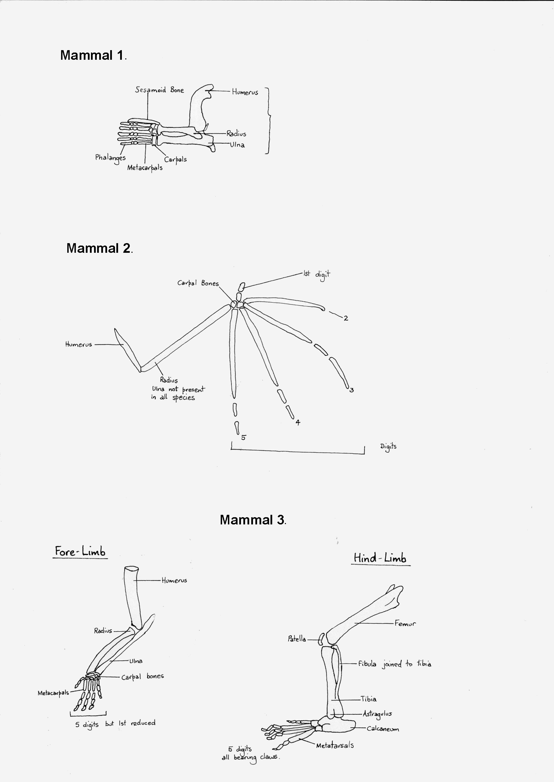

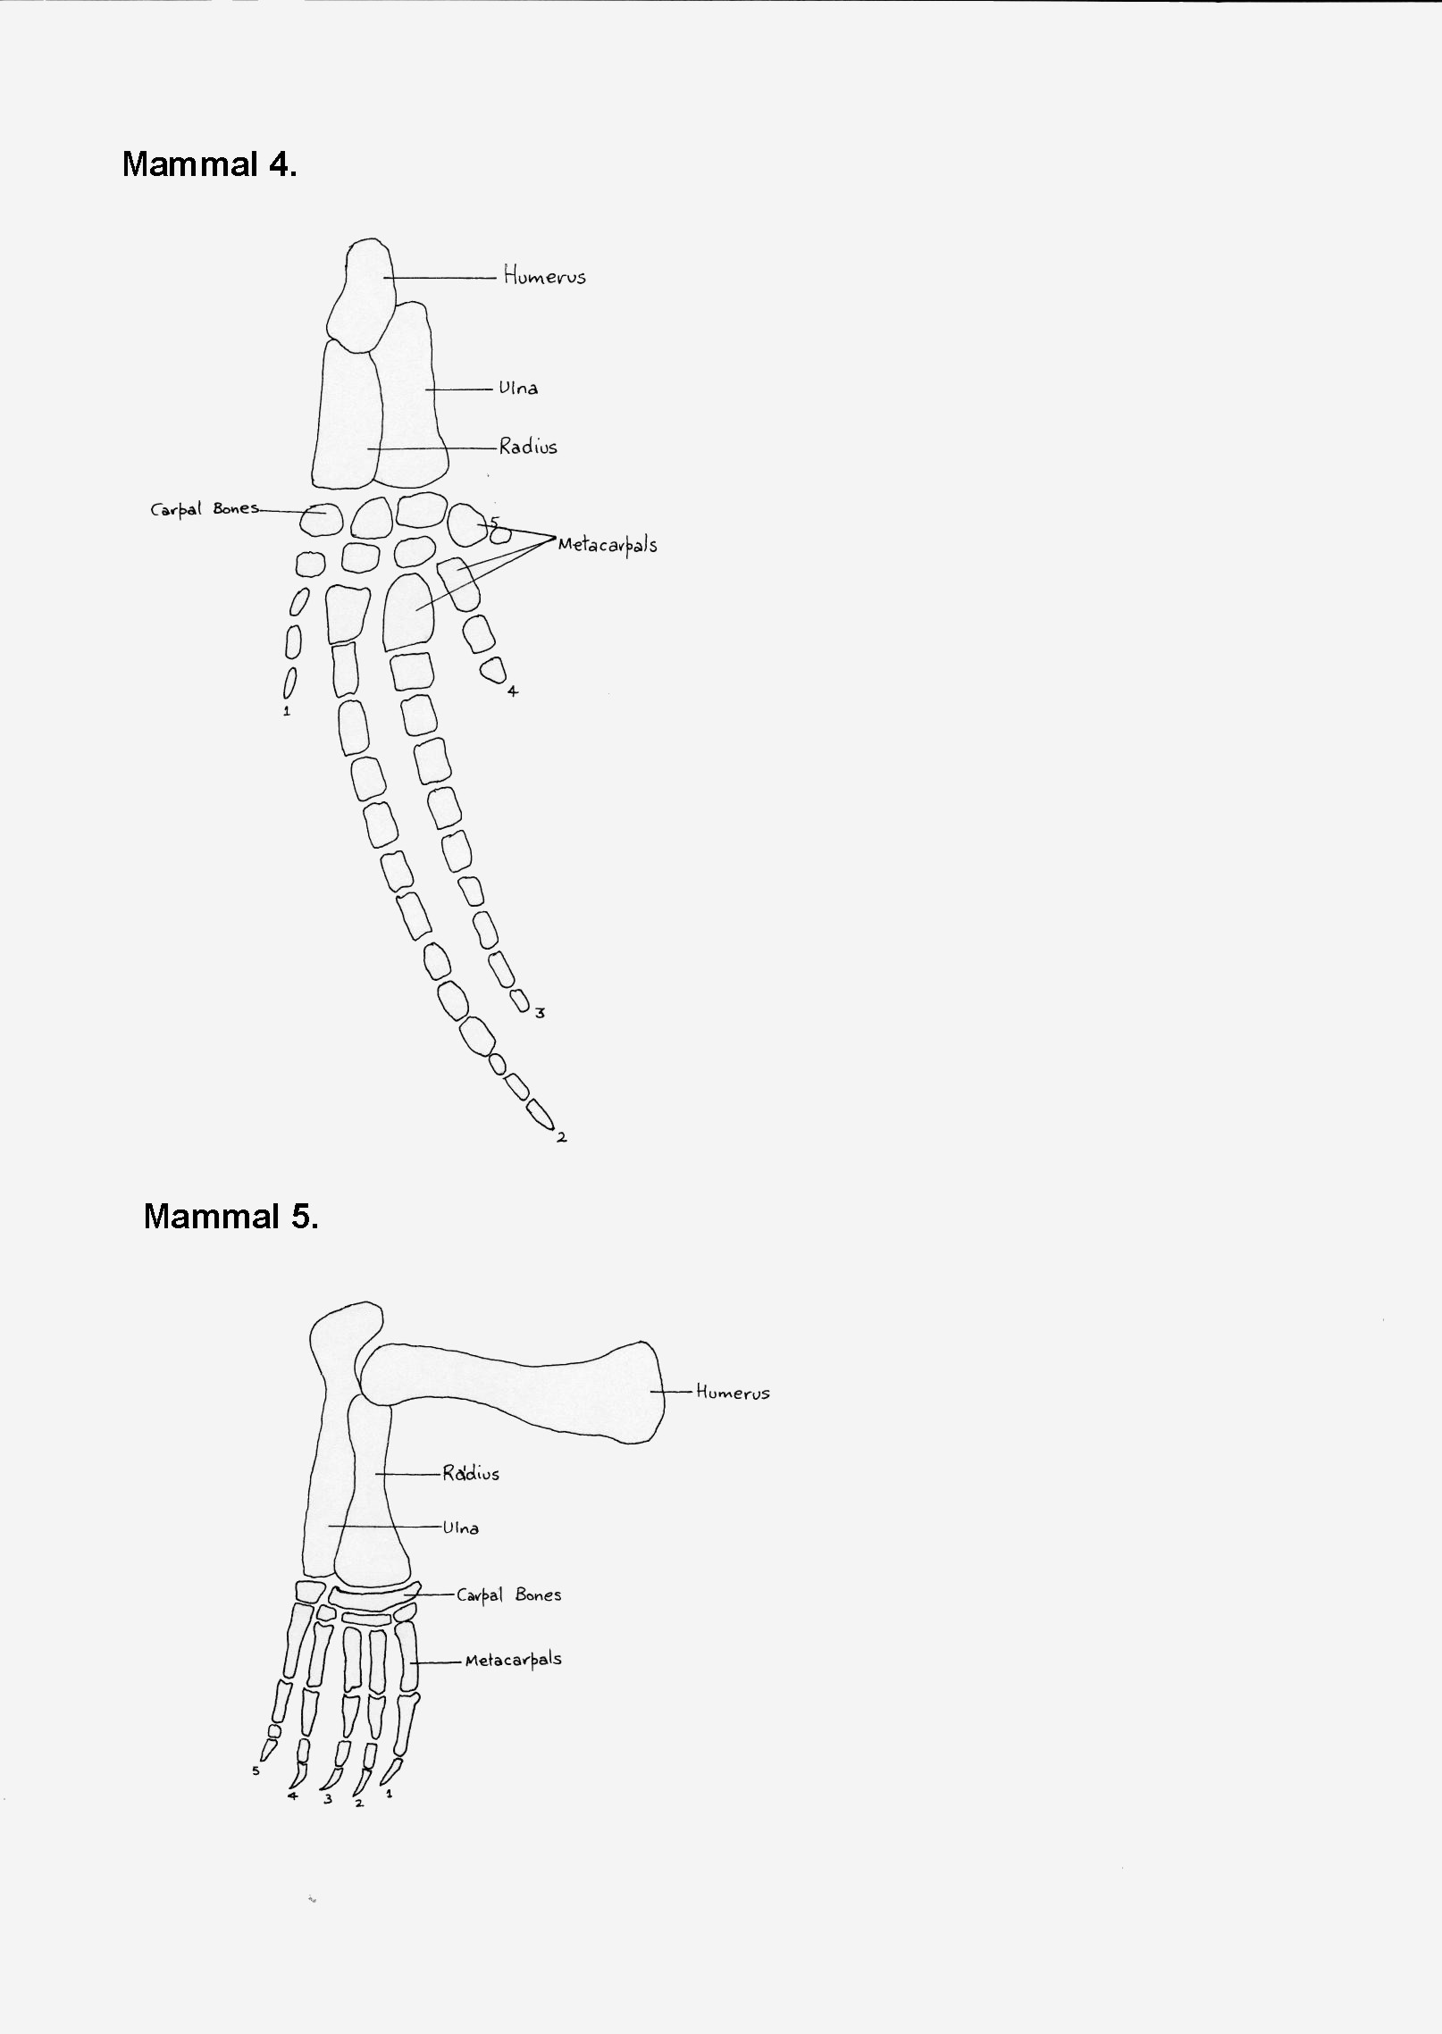
Bones of mammalian limbs

Part 2 Adaptation, looking for differences

Look at Figure 2. this is another version of the diagrams of limb bones of mammals and should help you to see if you were right in your answers to part 1.

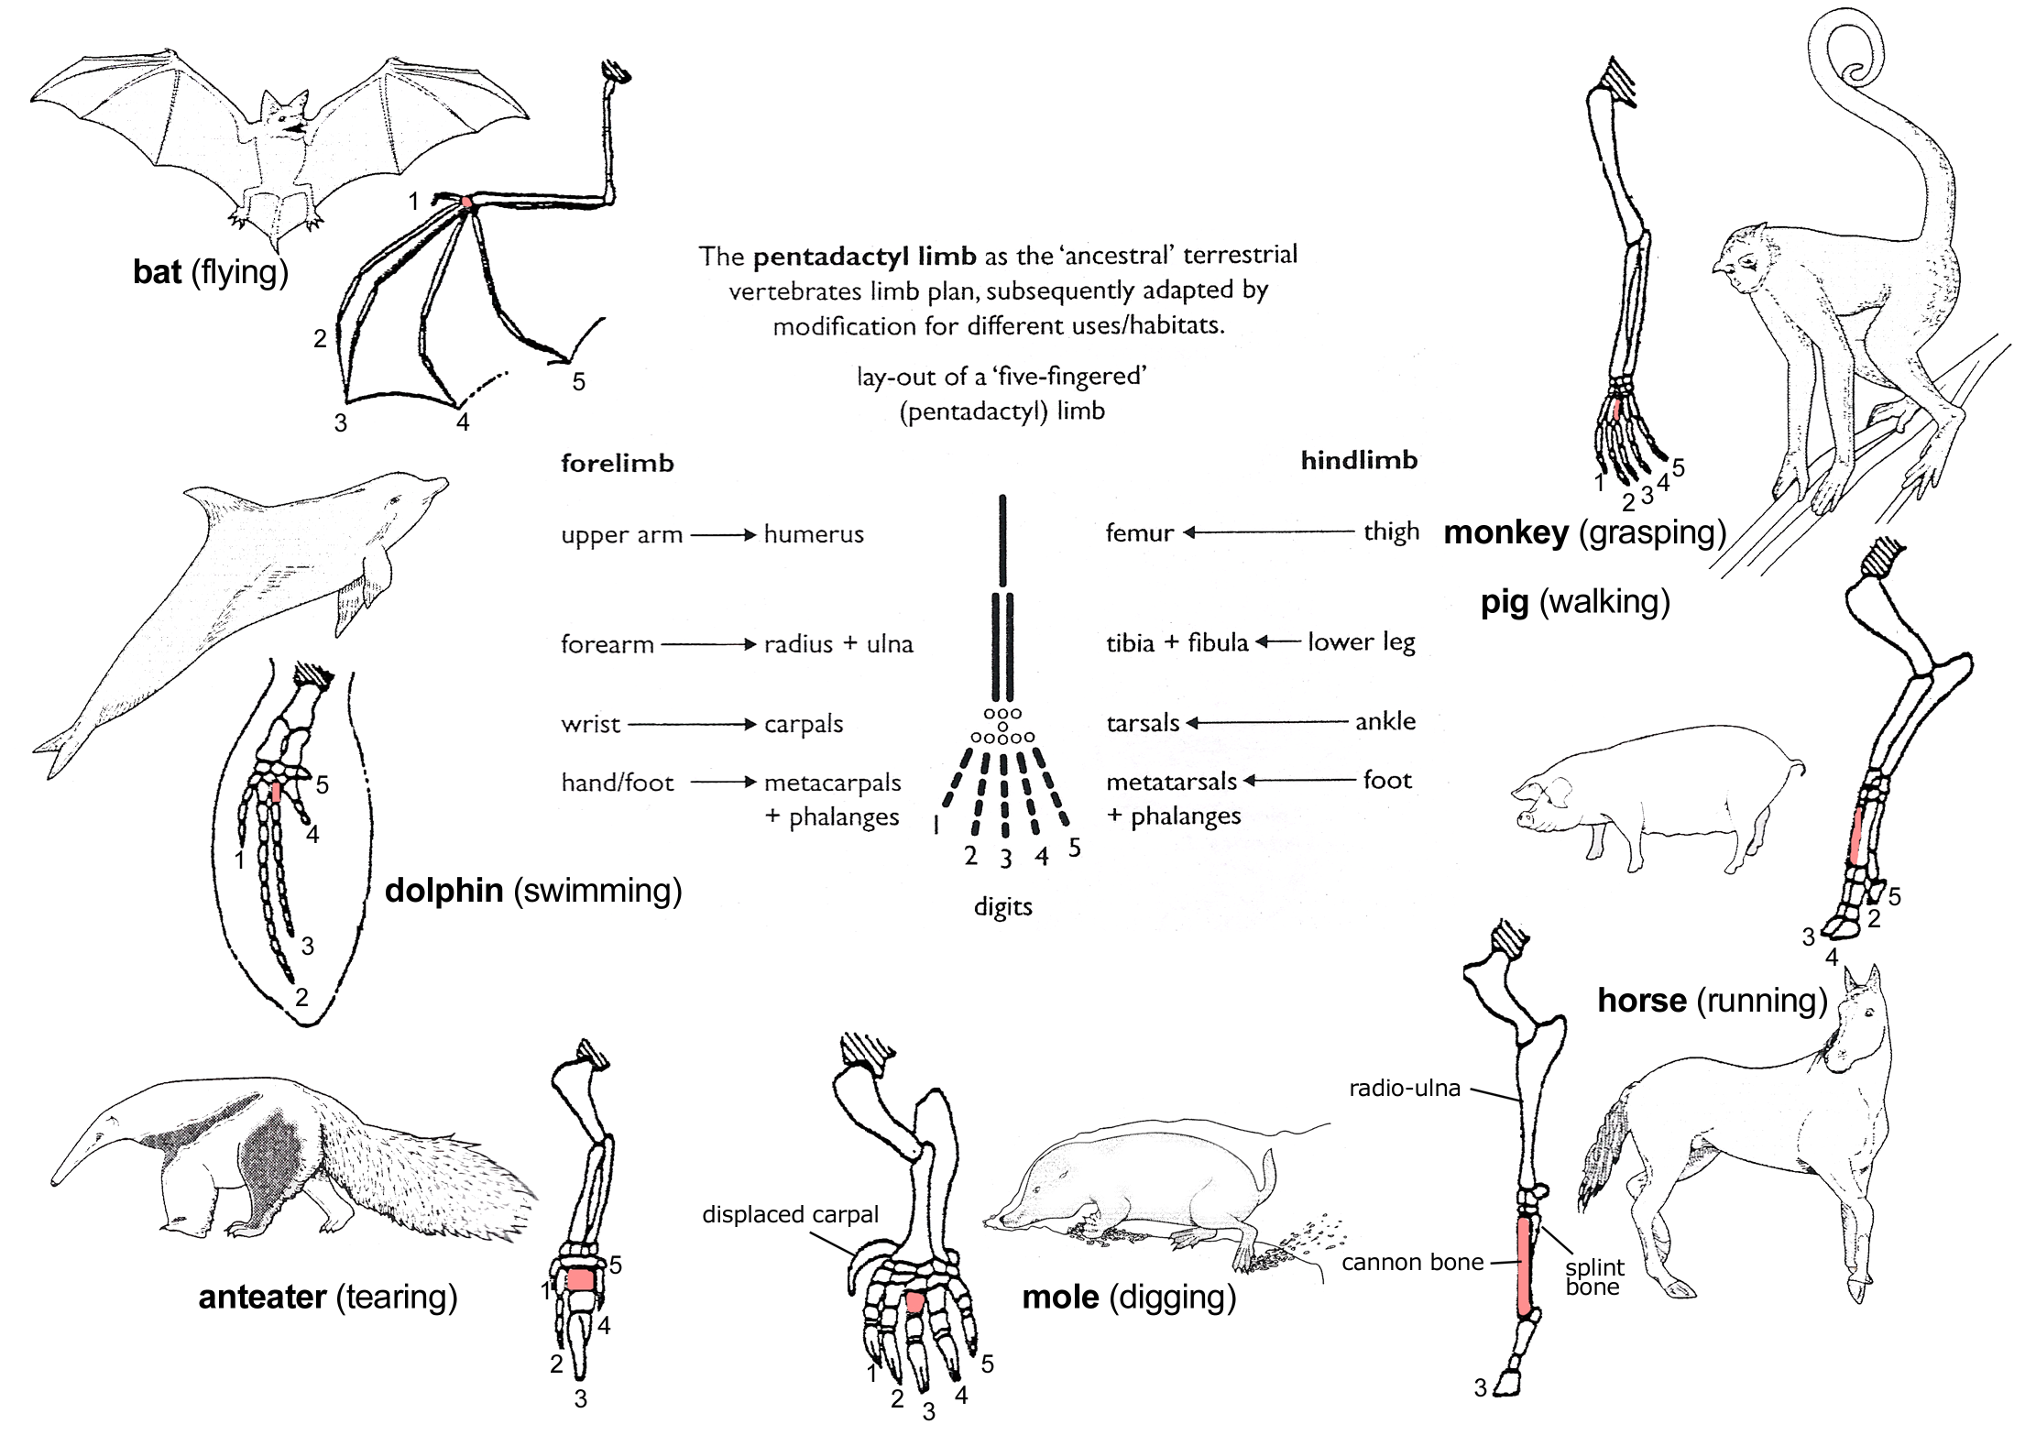
Fig 2 http://en.wikipedia.org/wiki/Image:Evolution_pl.png

1. How has the pentadactyl pattern been modified as an adaptation for flight in the bat?

2. How has the pentadactyl pattern been modified as an adaptation for swimming in the dolphin?

3. Comment on any other adaptations you have observed in Figure 2.

Part 3 But why is this evidence for evolution?

Homologous mammalian limbs demonstrate a pattern in the bones which has become adapted for different functions. Why did Darwin and others see this as evidence for evolution?

"What could be more curious than that the hand of man formed for grasping, that of a mole, for digging, the leg of a horse, the paddle of a porpoise and the wing of a bat, should all be constructed on the same pattern and should include similar bones and in the same relative positions?" C.Darwin

To understand this you need to consider for yourself how homologies came about.

1. Explain how the bone patterns in mammalian limbs came about, using the theory of evolution from a common ancestor.

2. Creationist or intelligent design ideas say that each species developed or was created separately. How would these ideas explain the homology of the bone structures in different species?

3. Based on the theory of evolution, what prediction would you make about the bone structures of
i) the limbs of fossils of early mammals
ii) the limbs of creatures that came before mammals?

4. Figure 3 shows the bones of one of the first creatures to live on land, long before there were any mammals. Does it fit the predictions made by the theory of evolution by natural selection?
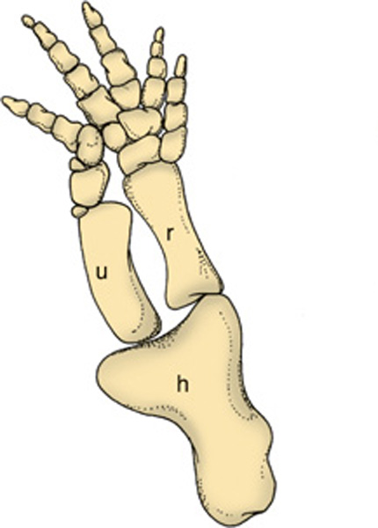

Figure 3

“Molecular homologies, such as the genetic code, now provide the best evidence that all life has a single common ancestor.” Mark Ridley in Evidence for Evolution.

