**Biology Standard 3.3.2 Summarize how transgenic organisms are engineered to benefit society.**

1. Put the following steps to creating a transgenic organism in order:

____ Put the DNA back into Organism 2

____ Insert the DNA into the DNA of Organism 2 (mix them)

____ Take the desired gene from Organism 1

____ Organism 2 has a new trait

____ Organism 2 undergoes mitosis

1. Explain in your own words what has taken place in the image below:

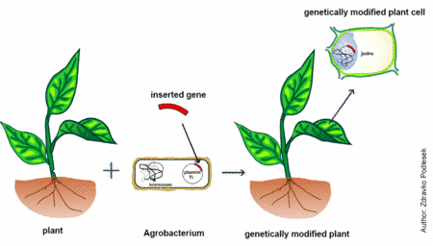

*Answer the following multiple choice questions:*

1. Which statement best describes the result of some of the processes involved in genetic engineering?
2. They alter the arrangement of hereditary material.
3. They provide energy for mitosis and meiosis.
4. They are necessary for normal gamete formation.
5. They reduce variation in organisms that reproduce asexually.
6. Strawberries have been created to resist the harmful effects of frost. This is an application of what?
7. Genetic engineering
8. DNA fingerprinting
9. Gene therapy
10. Cloning
11. A gene that codes for resistance to glyphosphate, a biodegradable weed killer, has been inserted into certain plants. As a result, these plants will be more likely to
12. Produce chemicals that kill weeds growing near them
13. Die when exposed to glyphosphate
14. Convert glyphosphate into sun energy
15. Survive when glyphosphate is applied to them
16. The technique illustrated in the diagram is most likely

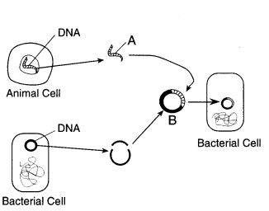

1. Cloning B. Protein synthesis C. Gel electrophoresis D. Genetic engineering
2. List three different ways that transgenic organisms are used in society.
3. For one of the ways that you listed above, list the pros and cons to genetically modifying organisms in this way.
4. Describe the role of a vector and give two examples.
5. Describe one potential ethical issue that could come about as a result of continued use of genetic engineering.

Cloning:

1. In your own words, what is cloning?

*Answer the following multiple choice questions:*

1. By which process can a group of genetically identical plants be produced from the cells of a single plant?
2. Screening C. Cloning
3. Genetic engineering D. Meiosis
4. The cloning of cells involves the process of:
5. Meiotic cell division
6. Mitotic cell division
7. Fusion of gametes
8. Separating DNA fragments
9. Which statement concerning an organism produced by cloning is correct?
10. The clone is genetically identical to its parents
11. The clone has the combined genes of both its parents
12. The genotype of the clone will be somewhat different from its parent
13. The phenotype of the clone will be entirely different from the parent
14. What technique is represented by the diagram?

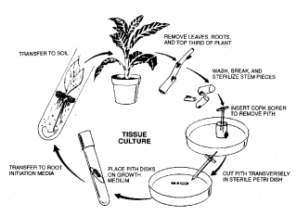

1. Hybridization
2. Genetic engineering
3. Cloning
4. Fertilization

**Biology Standard 3.3.1 Identify how DNA is used for comparison and identification of organisms.**

1. Draw a DNA fingerprint that shows three plants. Two plants should be of the SAME species, and the third plant is of a different species:

**Explain your drawing:**

**WHY are two plants more similar than the third?**

*Answer the following multiple choice questions:*

2. What is the process that is used to create a DNA fingerprint called?

1. Meiosis
2. Transgenic organism
3. Gel electrophoresis
4. Cloning

3. In order to make a DNA fingerprint, the pieces of DNA must be separated by which of the following?

1. Magnetic properties
2. Size
3. Shape
4. Number of amino acids

4. Which suspect is linked to the crime scene by this DNA analysis?

1. Suspect A
2. Suspect B
3. Suspect C
4. Suspect D
5. Using the image below, which plant species is most closely related to the common ancestor?

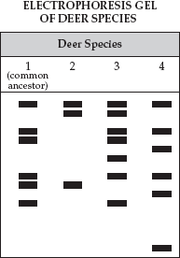

1. Species 2
2. Species 3
3. Species 4
4. They are equally related

6. Challenge!

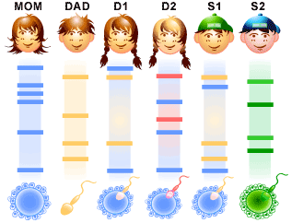

In this cartoon family, the mother and father have 1 adopted child and 1 child they had together. In addition, the mother had 1 child from a previous relationship and the father had 1 child from a previous relationship.

1. Which child is the adopted child?
2. Which child is the mother’s child from a previous relationship?
3. Which child did both parents have together?
4. Which child is the father’s child from a previous relationship?

7. What is the role of a restriction enzyme in gel electrophoresis?

8. Which DNA strands are going to travel the farthest? Why?

9. Explain what causes the DNA strands to move through the gel in electrophoresis?

10. What are four different ways (applications) that gel electrophoresis is used to compare DNA?